|  |  |  |  |  |  |  |  |  |  |  |  |  |  |  |  |  |  |  |  |  |  |  |  |  |  |  |  |
| --- | --- | --- | --- | --- | --- | --- | --- | --- | --- | --- | --- | --- | --- | --- | --- | --- | --- | --- | --- | --- | --- | --- | --- | --- | --- | --- | --- |
| |  | | --- | | First Name: Mikhail  Last Name: Mineev  Red ID: 820252323 |   The following scores have been recorded for you. Please notify the lab assistant if you notice any discrepancies.   |  |  |  |  |  |  | | --- | --- | --- | --- | --- | --- | | A1 | A2 | A3 | A4 | A5 |  | |  |  |  |  |  | | |  |  | | --- | --- | | Questions 1 |  | | Question 2 |  | | Question 3 |  | | Question 4 |  | | Extra Credit |  | | Total |  | |  |  | |

**Question 1**

|  |  |  |  |
| --- | --- | --- | --- |
| Criteria | Possible scores | Earned | Comments |
| 1. Proving relationship of high pass and low pass | 6 |  |  |
| 1. Separability of high pass mask | 5 |  |  |

**Question 2**

|  |  |  |  |
| --- | --- | --- | --- |
| Criteria | Possible scores | Earned | Comments |
| Gradients in x and y directions and magnitude | 3x3=9 |  |  |

**Question 3**

|  |  |  |  |
| --- | --- | --- | --- |
| Criteria | Possible | Earned | Comments |
| 1. Exploring color edge detection | 10 |  |  |
| 1. Identifying boundaries of objects | 10 |  |  |
| 1. Showing the boundaries | 10 |  |  |
| 1. Results and discussion | 10 |  |  |

**Question 4**

|  |  |  |  |
| --- | --- | --- | --- |
| Criteria | Possible | Earned | Comments |
| (a) Capturing real images on a street | 10 |  |  |
| (b) Proposing an algorithm to get the distance | 10 |  |  |
| (c) Program implementation | 10 |  |  |
| (d) Results and discussion | 10 |  |  |

**Extra Credit**

|  |  |  |  |
| --- | --- | --- | --- |
| Criteria | Possible | Earned | Comments |
| Quality of program, ideas , report and discussions. | 10 |  |  |

1. **QUESTION 1**

a)

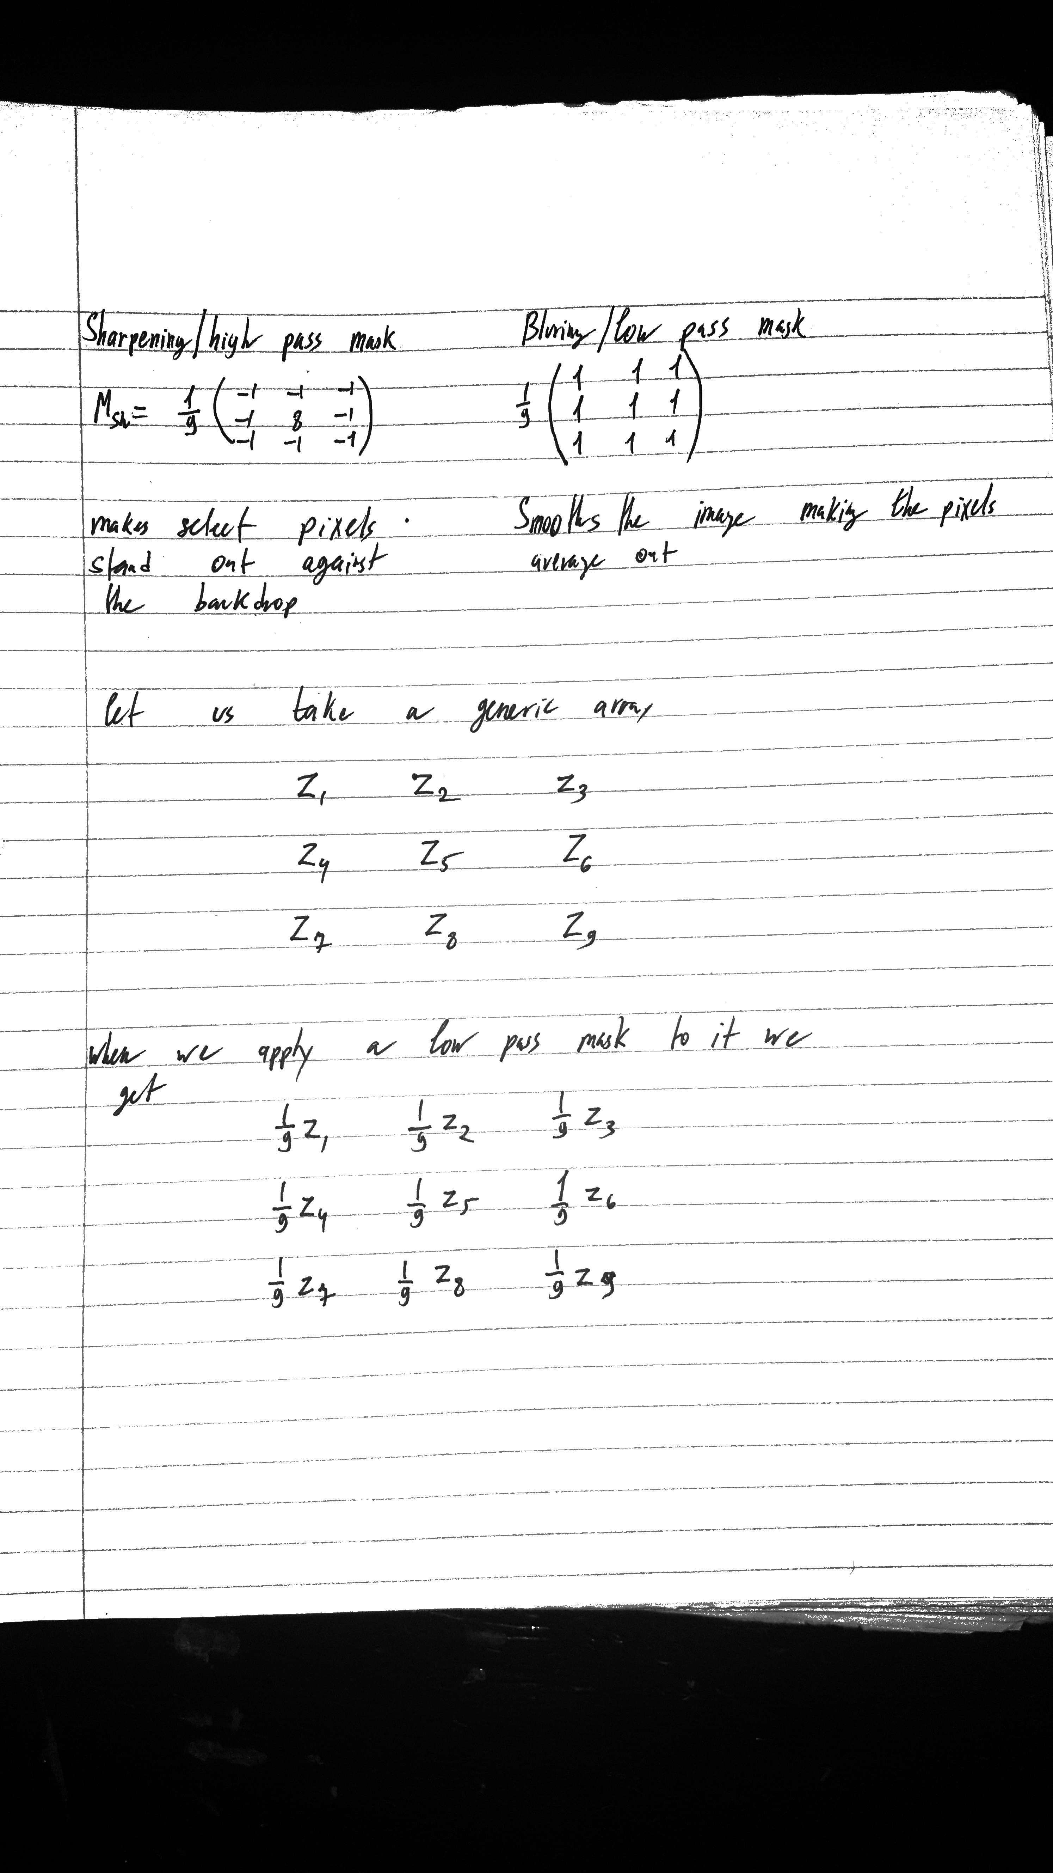

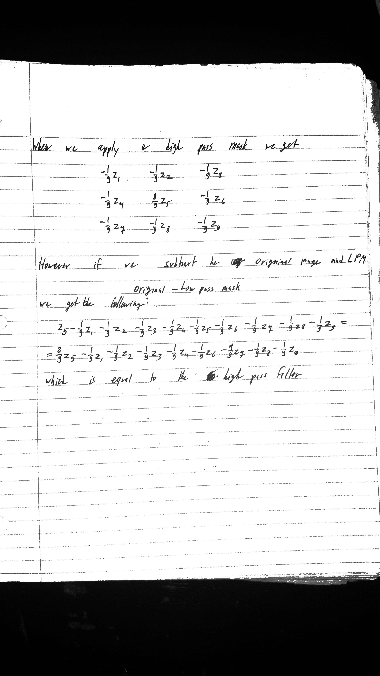

b) Using the above proof, we can see that the high pass mask in not separable.

By definition, a separable filter is made up of two or more smaller filters, but in the case of the high pass it is made by subtracting the low pass filter form the original image.

High Pass = Original – Low Pass

For computation a separable filter would mean doing multiple separate calculations and then doing one more calculation to combine them all together. This would allow for the programmer to write multiple different blocks/programs and then write just one program to combine the results of all others.

1. **QUESTION 2**

X Direction

|  |  |  |  |  |  |
| --- | --- | --- | --- | --- | --- |
| 0 | 0 | 0 | 0 | 5 | 15 |
| 0 | 0 | 0 | 5 | 15 | 15 |
| 0 | 0 | 5 | 15 | 15 | 5 |
| 0 | 5 | 15 | 15 | 5 | 0 |
| 5 | 15 | 15 | 5 | 0 | 0 |
| 15 | 15 | 5 | 0 | 0 | 0 |

Y Direction

|  |  |  |  |  |  |
| --- | --- | --- | --- | --- | --- |
| 0 | 0 | 0 | 0 | 5 | 15 |
| 0 | 0 | 0 | 5 | 15 | 15 |
| 0 | 0 | 5 | 15 | 15 | 5 |
| 0 | 5 | 15 | 15 | 5 | 0 |
| 5 | 15 | 15 | 5 | 0 | 0 |
| 15 | 15 | 5 | 0 | 0 | 0 |

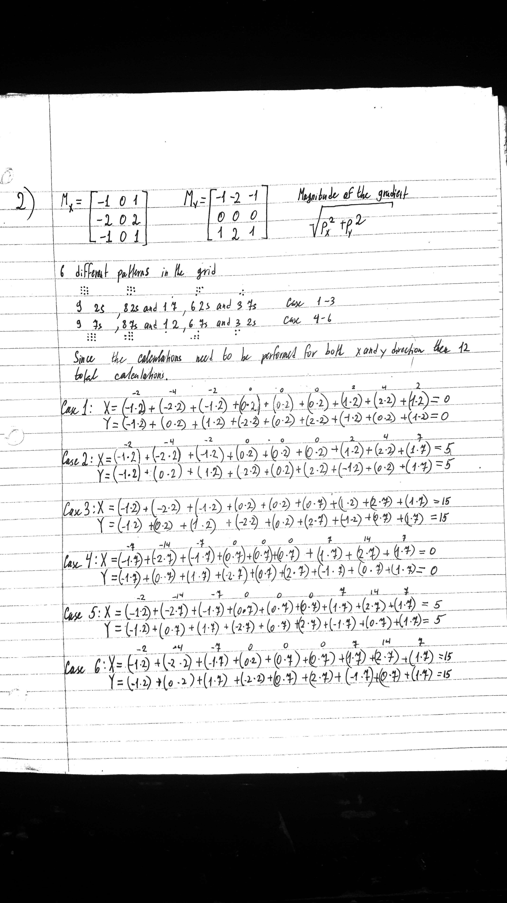

Gradient Magnitude

|  |  |  |  |  |  |
| --- | --- | --- | --- | --- | --- |
| 0 | 0 | 0 | 0 | 7 | 21 |
| 0 | 0 | 0 | 7 | 21 | 21 |
| 0 | 0 | 7 | 21 | 21 | 7 |
| 0 | 7 | 21 | 21 | 7 | 0 |
| 7 | 21 | 21 | 7 | 0 | 0 |
| 21 | 21 | 7 | 0 | 0 | 0 |

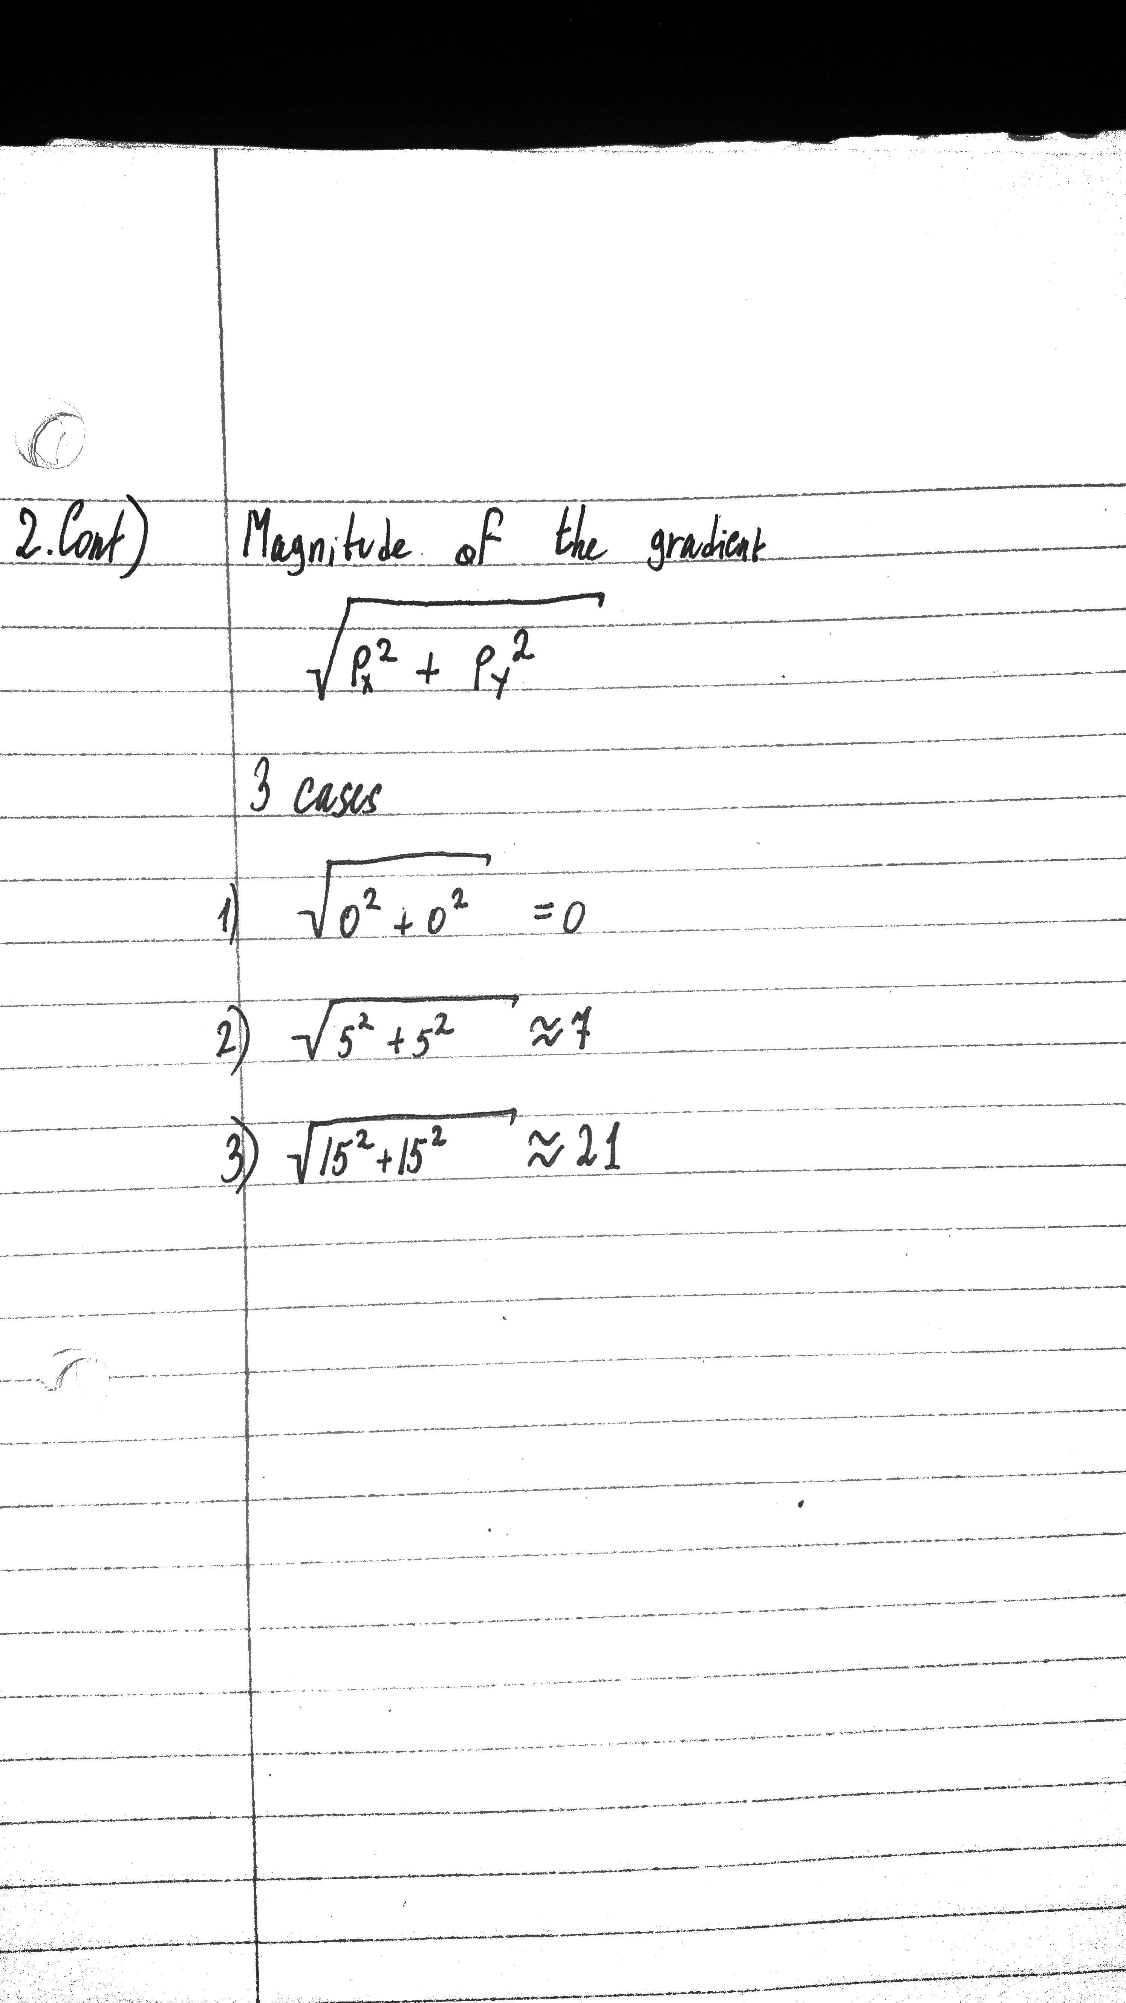

1. **QUESTION 3**

1 input = imread('IMAGENAMEHERE');

2 img = input;

3 for height = 1:size(img,1)

4 for width = 1:size(img,2)

5 if img(height,width,1) > 170 || img(height,width,2) < 60 || img(height,width,3) > 120

%RGB if red<85 or greewidth>100 or Blue >100

6 img(height,width,:) = [0 0 0];

%replace the selected pixel with black

7 end

8 end

9 end

10 gray = rgb2gray(img); % any of the nonblack pixels get turned gray to allow for sobel mask

11 BW = edge(gray,'sobel'); %applies sobel masks on edges

12 cEdge = reshape(uint8([0 0 255]),[1,1,3]) .* uint8(BW);

%changes the color of the edges on the sobel mask

%[0 0 255] change this for different colors

13 imshow(input+cEdge); %output the original image with the colored edge



I found a rather good way to find the edges of certain colors in an image. The way I did it is I isolated a certain color using code very similar to that of Problem 4 on Assignment 1.

But instead of turning every color that matches the set parameters a shade of gray I decided to turn it black. Then grayscale the entire image to allow the sobel mask to work, afterwards simply color the edge line to blue or some other color and combine the edge result with the original image. Here is the process for the image of the pepper provided with out code followed by my own image.

In this code I decided to filter out all pixels outside R > 170 || G < 60 || B > 120

The result after lines 1-9 is as follows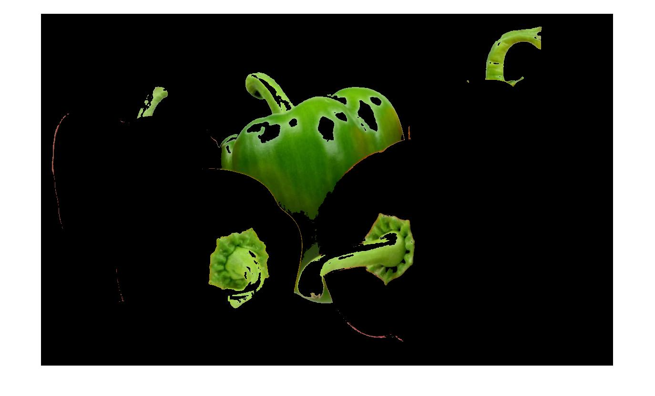

Next to allow for the application of the sobel mask we need to grayscale the image in line 10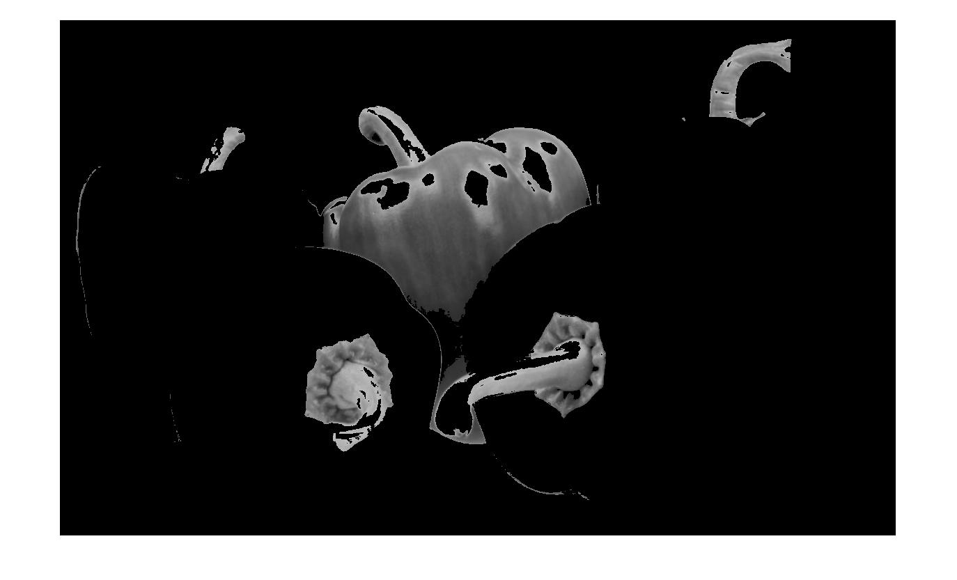

In line 11 we apply the sobel mask 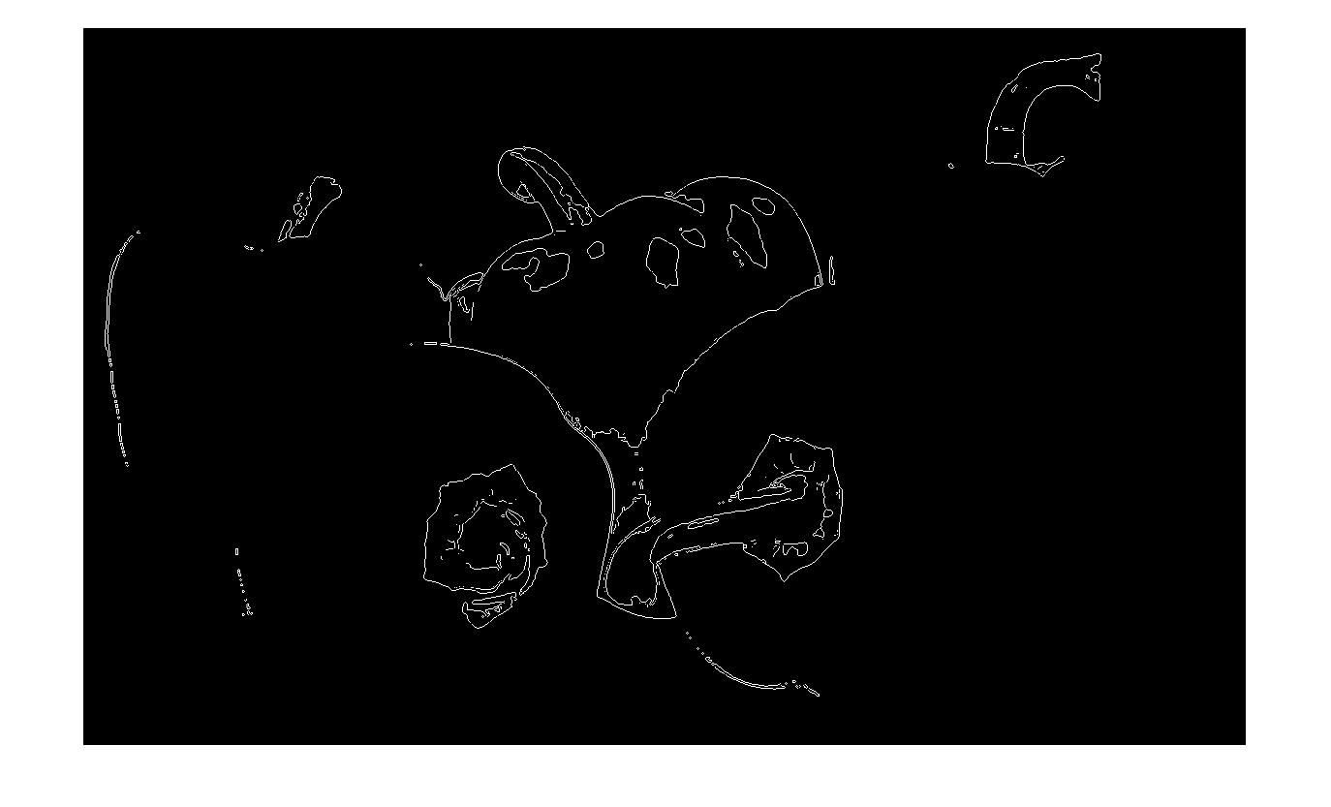

Then we color in the lines in the resulting image in line 12. We can change the color by changing these values [0 0 255]. The code makes them blue but we can change them to any other color, for example purple [255 0 255].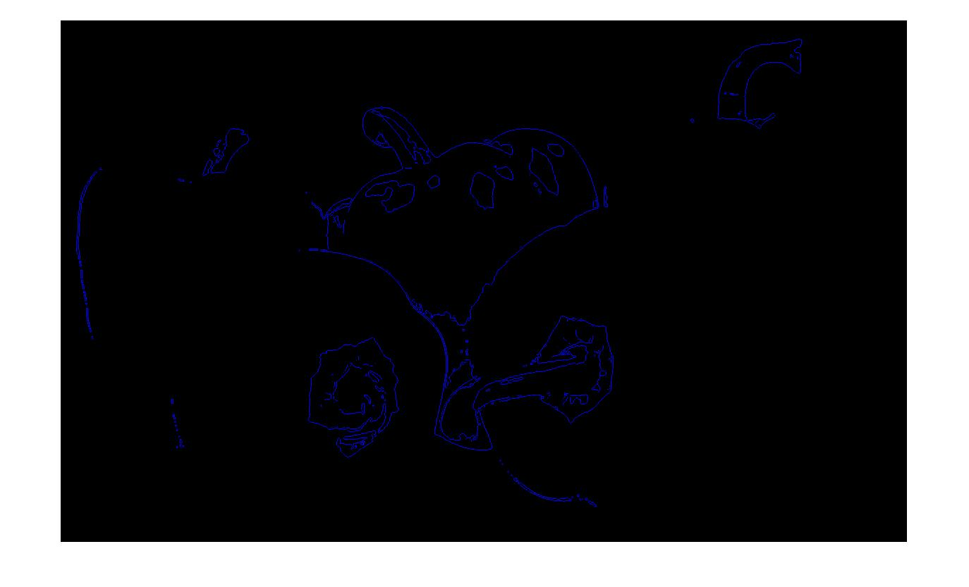

Lastly we combine the original image and the colored edges in line 13 to get the following image.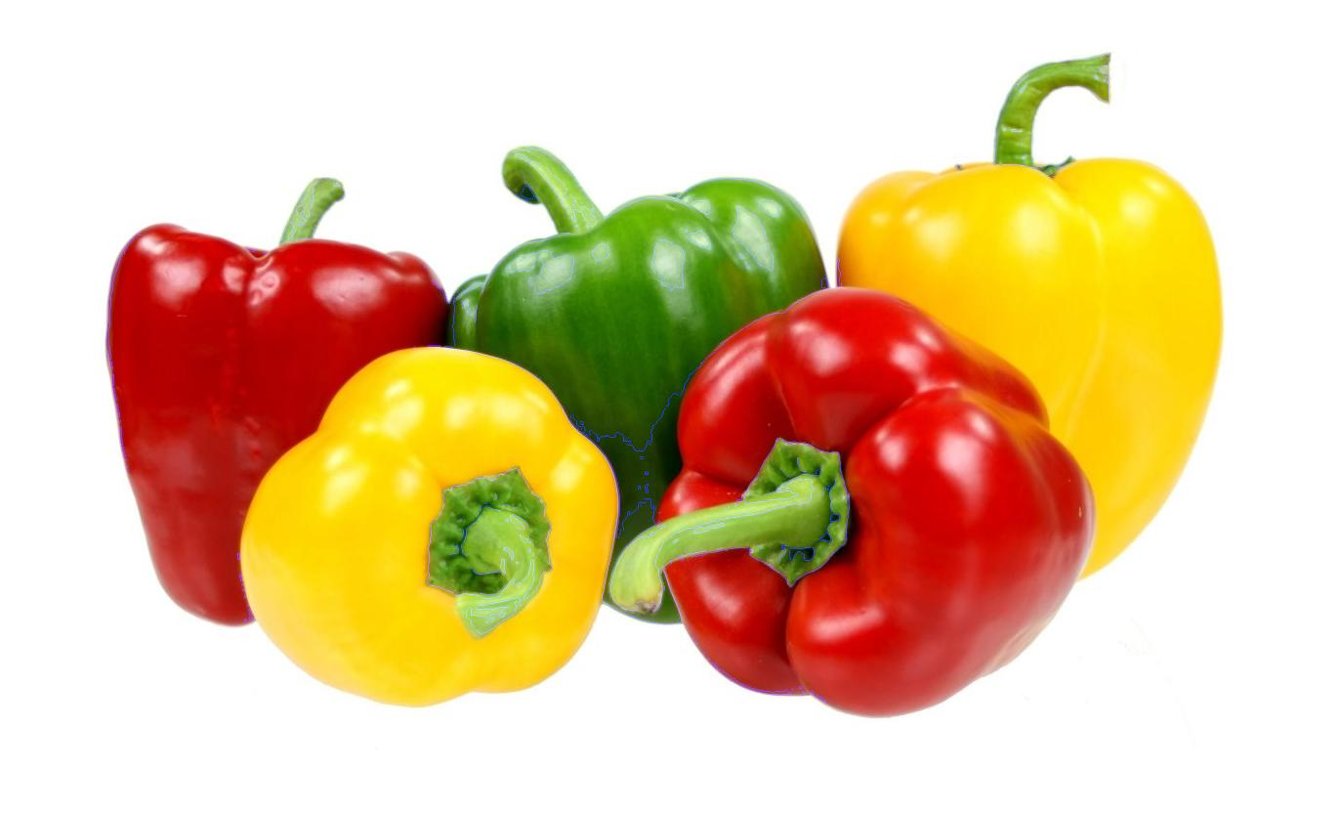

If we modify the edge color values to be cyan, [0 255 255], than our result is more visible. 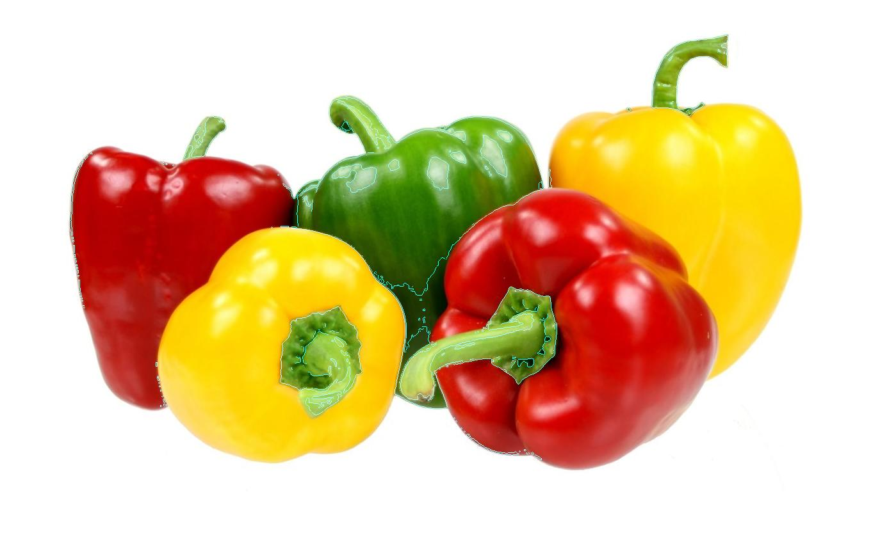

To demonstrate it with our own image we will use this, and make the color of the edges be red, [255 0 0].

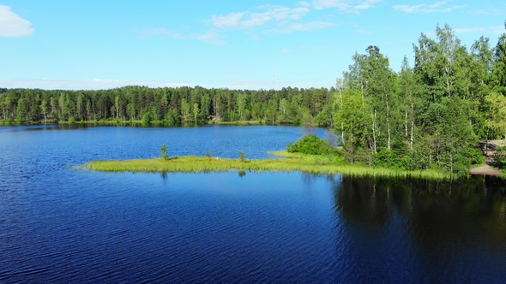

We go from the image above to this 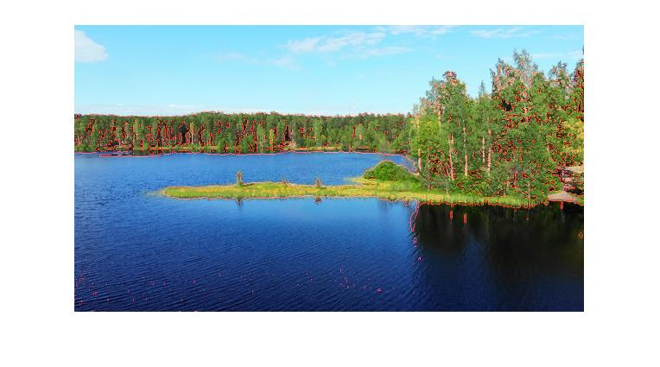

Overall I am surprised how simple a seemingly hard operation is, however the one hurdle that I still have not overcome is the bleeding of other colors into the edges. The pepper image has many hues of red and yellow be visible after line 1-9. Similar things happen to the lake image, but they are not as visible. This can be corrected after minute adjustments of the filtering values, however with this method I doubt it can be perfect since as we can see some parts of the green stems were turned black with these settings.

1. **QUESTION 4**

For this program I used a video camera to record my car on a backdrop as I was driving past a distinctly colored reference object. In order to calculate the car’s speed as well as distance traveled I need 3 things to be known, camera speed, number of frames between the 2 images used and the length of the reference object.

Camera was recording at 30 fps, the 2 images are frame 1 and frame 5, meaning the car traveled that distance in 0.16667 seconds and the object length is 125 centimeters.

FRAME 1

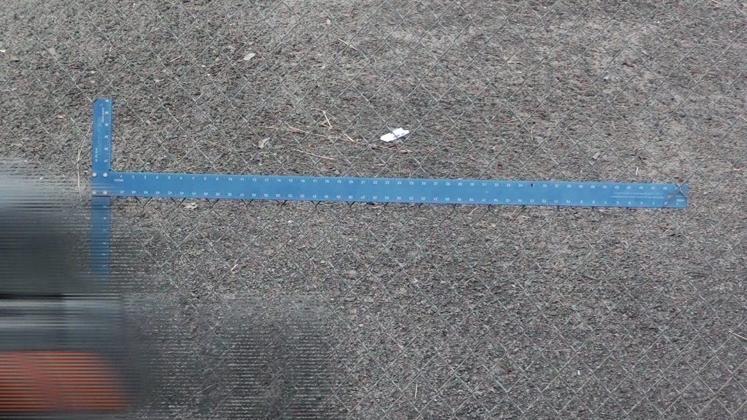

FRAME 5

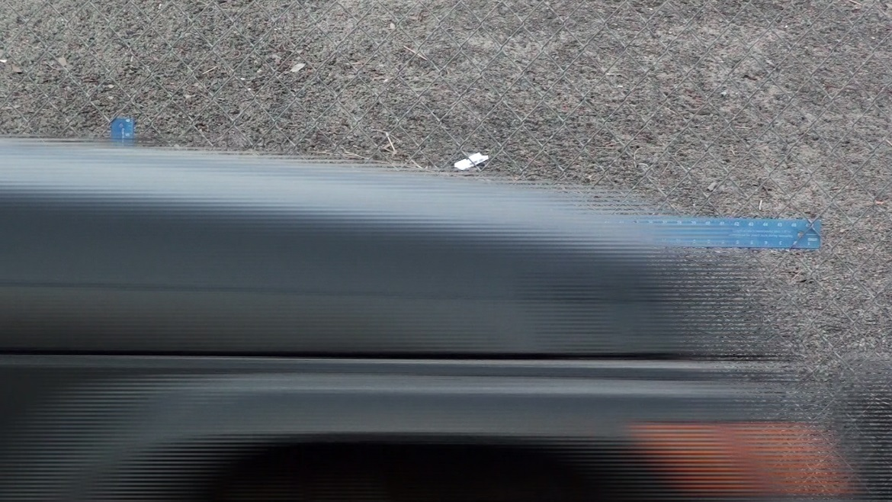

What I decided to do was use the same code as I did for number 3 to isolate the distinctly blue pixels in both images. 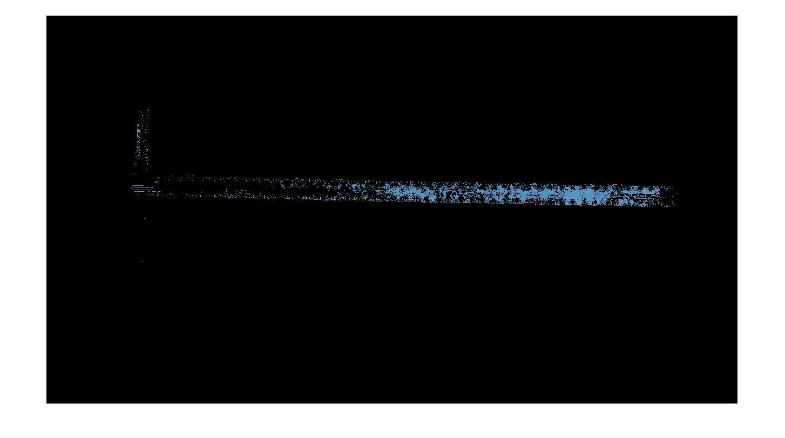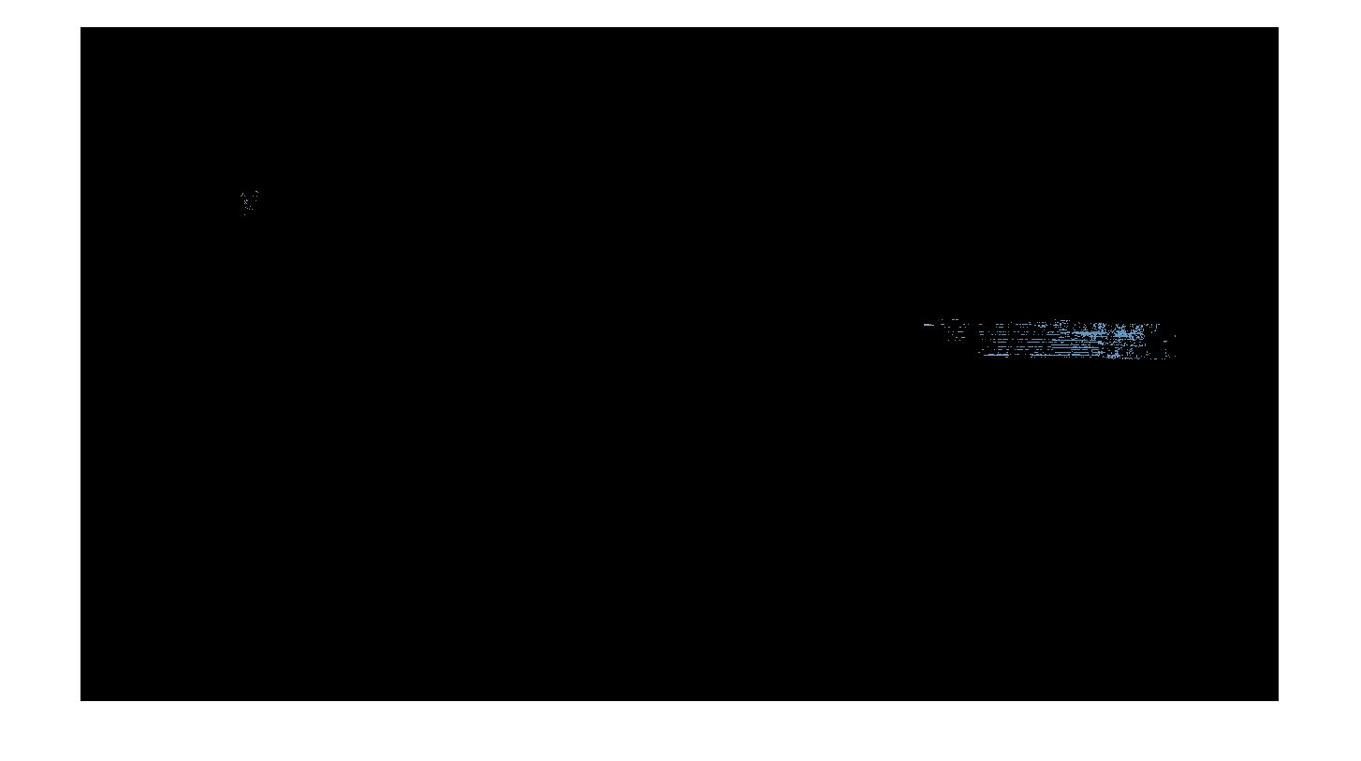

Taking Frame 1 as 100% of blue pixels I calculated the percent of blue pixels left after frame 5. Getting the distance traveled and then the speed using the following code.

F1 = imread('Frame 1.png');% read in first frame

F5 = imread('Frame 5.png');% read in fifth frame

var1 = 0; %number of blue pixels in image 1

var2 = 0; %number of blue pixels in image 2

for height = 1:size(F1,1)

for width = 1:size(F1,2)

if F1(height,width,1) > 160 || F1(height,width,2) > 160 || F1(height,width,3) < 190

%RGB if red>160 or greewidth>160 or Blue <190

F1(height,width,:) = [0 0 0];

%replace the selected pixel with black

else

var1 = var1+1;

end

end

end

for height = 1:size(F5,1)

for width = 1:size(F5,2)

if F5(height,width,1) > 160 || F5(height,width,2) > 160 || F5(height,width,3) < 190

%RGB if red>160 or greewidth>160 or Blue <190

F5(height,width,:) = [0 0 0];

%replace the selected pixel with black

else

var2 = var2+1;

end

end

end

%calculate percent of ruler left visible after 5th frame

k = ((var2 .* 100)./var1)./100;

%calculate amount of centemeters traveled on the ruler

traveled = (125 - (125.* k)) ./ 100;

tRound = round(traveled .* 100);

%lastly calculate the distance the car would travel in 1 second if this is

%the distance traveled in 5 frames i.e. 5/30th of a second

metersPerSecond = round(traveled ./ 0.166667);

%convert to miles per hour

mph = round(metersPerSecond .* 2.2369);

disp (var1)

disp (var2)

fprintf('Distance traveled: %d centemeters\n', tRound);

fprintf ('Speed: %d miles per hour\n', mph);



Breaking down the above calculations we get var1 = 25666 and var2 = 3836

Which allows us to get the distance of 106 centimeters and speed of 13 miles per hour.

One Problem that I see occurring with this method is if the distribution of the blue pixels is not even across the reference object like in our images. This might have contributed to the error in the calculations as I was going 15mph for the test.

Another source of error is the camera speed, if the camera I used was filming at 60 or 120 frames per second it would have been possible to get a better reading from the images without the obstructive blurring that is obvious on the front portions of the car.